***The God Father***

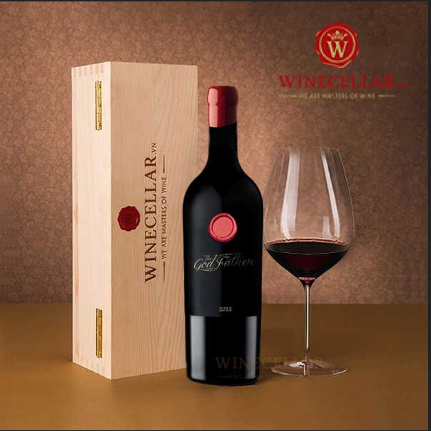

*The Godfather Cabernet Sauvignon Italian red wine - The Godfather, made from Cabernet Sauvignon grapes Gala Dinner No Menu in July 2019.  
  
Godfather Cabernet Sauvignon wine was inspired by the movie The Godfather - Godfather to name the wine bottle. Bottled and luxuriously waxed to make Godfather Cabernet Sauvignon more impressive."*